Hadoop [YARN]

- YARN stands for “Yet Another Resource Negotiator”.

Hadoop 1.0

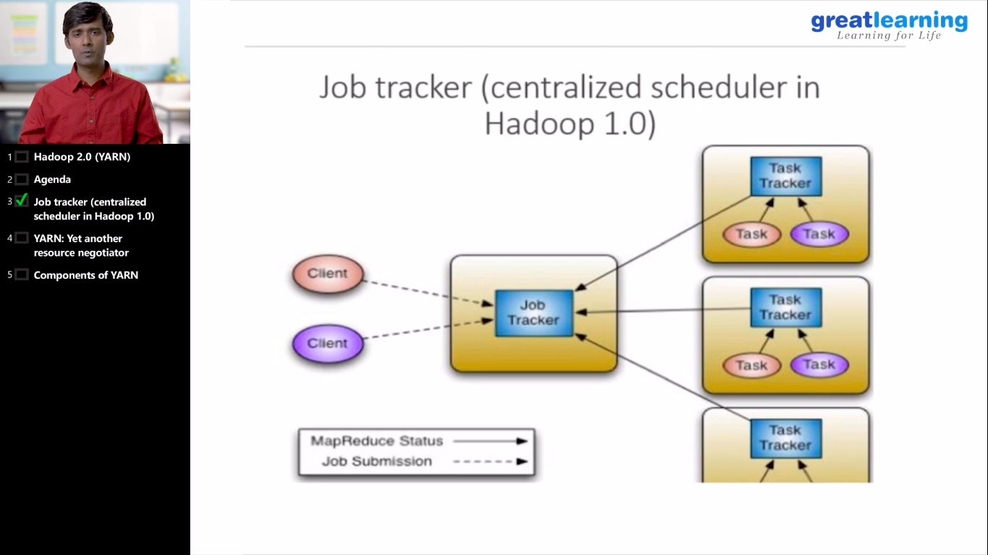
In Hadoop 1.0, We have the Job Tracker with Centralized Job Scheduler. The responsibility of the Job Tracker is to split up the job into smaller task and these task are going to be distributed on multiple data node. And these individual task are going to be monitored by the task tracker and report the status back to the job tracker. The drawback in this approach is that, for launching of every task, we need to assign certain resources. Means, each task is now going to be a Java program. So a Java program runs on JVM. This JVM container needs to have predefined setup resources, that is how many virtual CPU, RAM is given to the JVM. So, all the details should be per-configured and is kept in a static way.

Because of per-configured resources, the scalability of the number of Job is limited in Hadoop 1.0, and also the job tracker takes the responsibility of both resource negotiator(allocating the resources to each task with the help of the data node), as well as making sure that the scheduling of the job is happening correctly. So, taking care of resource management and scheduling into a single component.

Another drawback is that, it’s heavily loaded and the resources are not dynamically allocated on data node. One more drawback of Hadoop 1.0 is that, the number of data node cannot go beyond 4000. So, you cannot have a cluster of size beyond 4000.

